**Анализ системых ошибок**

**Ошибки сервера приложений**

**Runtime error TSV_TNEW_OCCURS_NO_ROLL_MEMORY occurred**.

− Program or user is using all the shared area the server.

− Try to increase the value to higher value as its quite low in your system - can set up to 80-100 MB.

**abap/shared_objects_size_MB** = 100 – тр. **rz11**.

Just check the sappfpar at os level before restarting.

− Refer to the NOTE - 1957297. This might solve your query.

**Runtime error TSV_TNEW_PAGE_ALLOC_FAILED occurred.**

## ***Analysis of scenario #1***

The required analysis begins in the **ST22** transaction where more information on the dump can be checked. Once in ST22, select the desired occurrence of TSV_TNEW_PAGE_ALLOC_FAILED and scroll to the "Memory consumption" area. This area reports the memory usage at the time of the dump. We have below one example of such information (please be aware that the dots were added in fields "EM" and "Heap" for education purposes)

## ***Analysis of scenario #2***

Go to **ST02** transaction. Our focus - on the SAP MEMORY tab. We look now to the *Extended memory* field where simple by relating the two fields *MaxUse* and *In Mem* - its possible to confirm that at least once in the current uptime - all of the extended memory was used. Assuming that it was our dump the responsible - the current Extended memory of the instance was around 11GB /from the 12 GB available/ and our program has allocated just the 1GB that not yet taken.

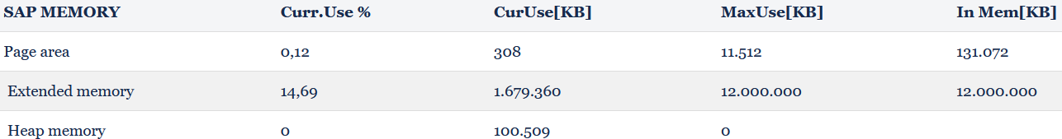

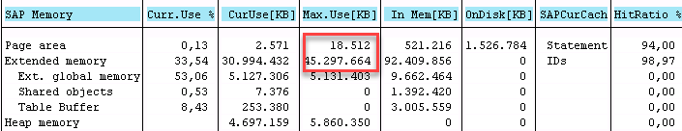

The quota of extended memory EM per platform is defined by

**ztta/roll_extension** - defines the quota of extended memory - EM. If the value shown in the dump for EM is much lower than this parameter it is generally because the total amount of EM that can be allocated by ALL sessions of an application server has been reached. This can be confirmed in transaction ST02. For additional AIX memory parameters, see [SAP Note 789477](https://service.sap.com/sap/support/notes/789477).

00O2TN6ZGQI1W2JGRWVPWEXV0